Section 4(ii) & (iii) | Team Structure, Experience and Qualification of the Team
6.0 | Property Management Services Provider
6.1 | Student Engagment and Communnity Services Provider

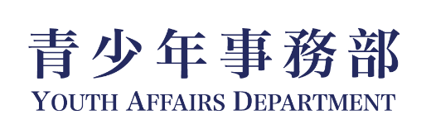
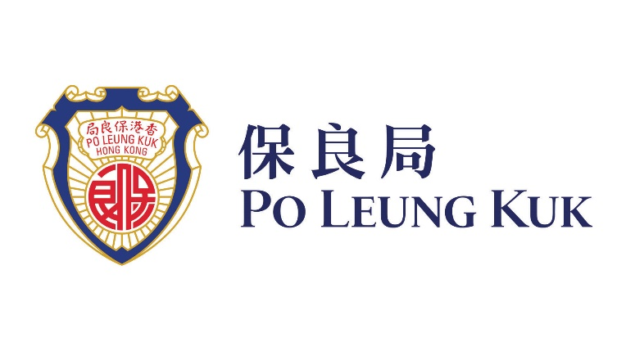

  - Relevant Project Reference

1.2.1 Similar Projects

Project: | Po Leung Kuk Lee Shau Kee Youth Oasis
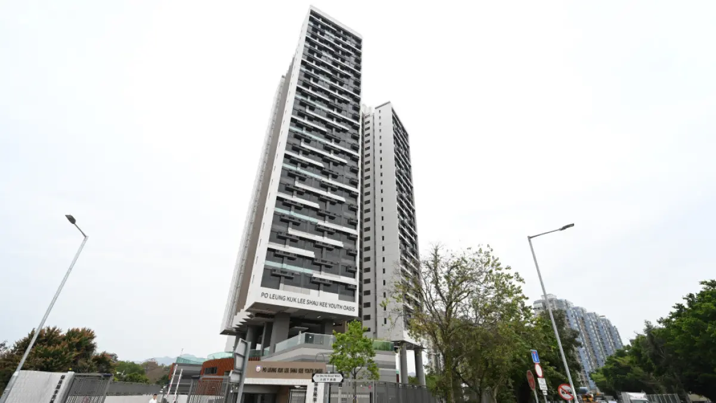

“Po Leung Kuk Lee Shau Kee Youth Oasis” (保良局李兆基青年綠洲), is the largest project under the government's Youth Hostel Scheme, located at 18 Tai Shu Ha Road West, Yuen Long, is operated by Po Leung Kuk.

It is 27-storey building, providing 1,680 hostel places for working youth aged 18 to 30. The project has successfully established a scalable and sustainable youth hostel operation model. To date, it has served approximately 2,000 young residents, organized around 700 programmes with over 33,400 participant attendances, and built a volunteer team of more than 2,500 youth members contributing over 14,000 service hours.

The provision of Youth Services at Youth Oasis, including the followings:

“Youth Oasis” aims to promote the holistic development of young people by establishing a diverse and integrated service platform that addresses their needs in physical and mental wellbeing, capacity building, social participation, and sustainable development. Anchored by four core service streams, the programme adopts a systematic and coherent activity design to nurture positive values, enhance individual competitiveness, and encourage active community engagement, thereby fostering both personal and societal growth.

- Healthy Living
This stream promotes positive development in the physical, mental, and spiritual dimensions of youth, supporting their psychological and social wellbeing. Through a range of activities such as mindfulness self-awareness workshops and singing bowl stress-relief sessions, participants are guided to cultivate a balanced and sustainable healthy lifestyle.

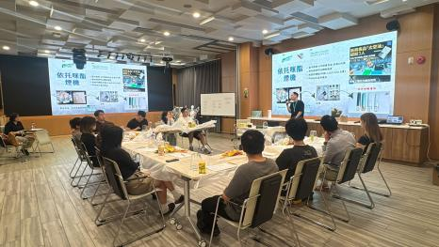  Anti-Drug Floral Art Workshop | 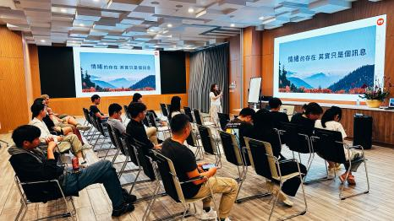  Mental Health Education Talk – Emotional Self-Awareness
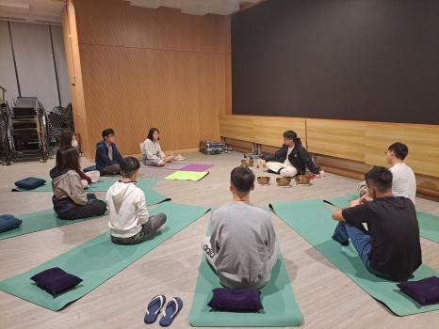
Singing Bowl Experience Workshop

2. Financial Planning
This stream focuses on strengthening youths’ career readiness, financial literacy, and entrepreneurial capabilities. It aims to cultivate sound financial habits and equip young people to plan effectively for their future, while providing diverse training and practical opportunities to support entrepreneurial exploration and enhance their understanding of different industries for informed career planning. Key initiatives include the “Learning Finance through Stories” series co-organised with the Investor and Financial Education Council, as well as financial planning workshops, one-on-one financial advisory services, and the “Career and Financial Literacy” workshops delivered in collaboration with the Mandatory Provident Fund Schemes Authority (MPFA).

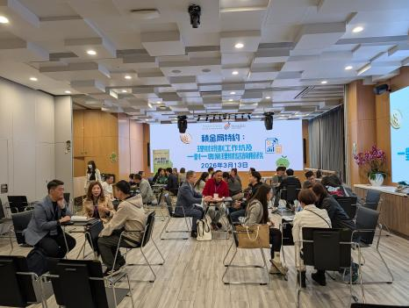  Financial Education – One-on-One Personal Advisory Service | 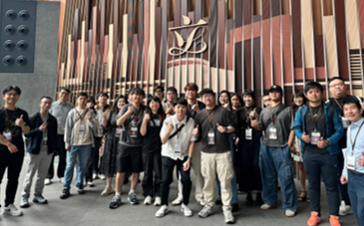  Legislative Council Visit
3. Volunteering
This stream develops youths’ capacity to plan and implement community service initiatives, fostering connections with underprivileged groups and promoting the value of “helping others to help themselves.” Activities include outreach programmes such as International Children’s Day visits and the summer “Care for the Elderly” campaign.

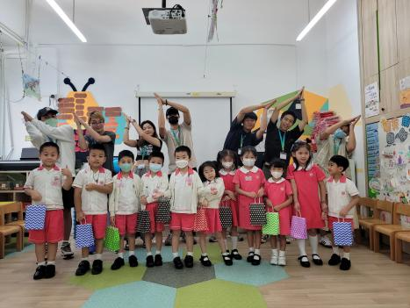  International Children’s Day Outreach Visit for Children | 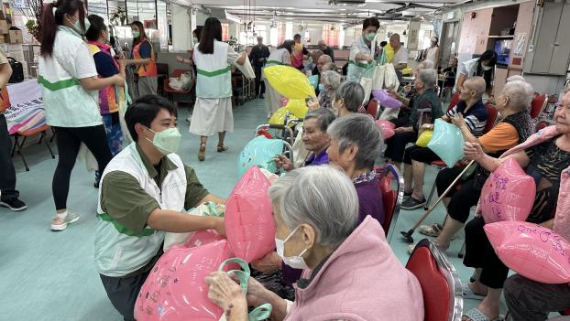  Summer “Care & Compassion for the Elderly” Activity

4. Green Culture
This stream enhances environmental awareness and encourages practical sustainable actions among youth. Through initiatives such as coastal clean-up programmes and visits to environmental education centres, participants are encouraged to integrate sustainability into their daily lives and develop a responsible attitude towards environmental stewardship.

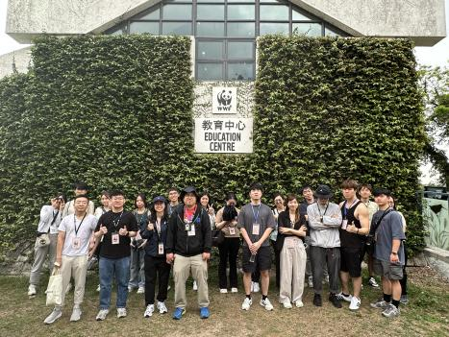  Visit to Environmental Education Centre | 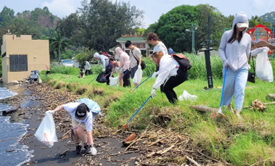  Coastal Clean-up and Environmental Stewardship Activity

Project Cost: | HK$33.4M
Completion: | 2025-2028
Funder & Overseer | The Education University of Hong Kong

  - Duties and Responsibility

The Duties and responsibility of the core personnel are as follow:

Name (Position) | Duties and Responsibility
LEE Tak Wai  Service Manager, Student Engagement and Community Programming  (On-site Team)  Report to Property Manager | Mr. Lee Tak Wai is a Registered Social Worker and will be the Project-in-charge on- and off-site for the hostel community services. He will oversee the planning and management for the hostel community services for the project. He will act as the Deputy of the Project Manager in case Ms Chan Siu Yu on leave. He will be responsible for the followings:  - Provide timely counselling and advisory support to exchange hostel youth in need, and make appropriate referrals as necessary.  - Respond immediately to serious incidents and emergencies.  - Oversee the overall on-site service operations, including activity planning, resource management, and service quality monitoring.  - Supervise the day-to-day implementation of services and collaborate with the team to discuss service content and direction.  - Provide guidance and professional advice to the team to ensure the quality and smooth execution of activities.  - Lead the team in conducting service quality and performance reviews, and formulate plans for continuous improvement and optimisation.  - Maintain close and positive relationships with partners.  - Manage personnel and project-related administrative tasks.
CHAN Siu Yu  Project Manager, Student Engagement and Community Programming  (On-site Team)  Report to Service Manager | Ms. CHAN Siu Yu is a Registered Social Worker and will lead the hostel community service team onsite and be responsible for the followings:  - Provide timely counselling and advisory support to youth staying in exchange hostels as needed, and make appropriate referrals when necessary  - Responsible for the implementation and management of designated projects, coordinating various service activities including event dates, venue arrangements and support, manpower deployment, etc.  - Ensure all activities are carried out as planned and that pre-set goals are achieved  - Provide guidance and professional advice to the team to ensure service quality and smooth execution of activities  - Maintain close and positive working relationships with partner organisations  - Liaise and coordinate with relevant parties and stakeholders when organising community activities  - Discuss and formulate annual plans and budget with the team on a yearly basis
AM Tsz Ying  Project Officer, Student Engagement and Community Programming  (On-site Team)  Report to Project Manager | Ms. LAM Tsz Ying will be the Chief Project Officer onsite and provide full support to the Service Manager and Project Manager the followings:  - Interact directly with youth and assist in the planning and execution of activities  - Prepare necessary materials and equipment for activities  - Liaise with external parties, including hostel residents, volunteers, and service providers  - Provide administrative support, including document preparation, meeting coordination, recruitment, and financial arrangements  - Manage resources, including supplies and assets, and maintain relevant records  - Assist in promotion and publicity efforts  - Handle team document organisation, data entry, and database maintenance  - Manage service procurement  - Prepare activity and financial reports
LO Chun Leung  Project Officer, Student Engagement and Community Programming  (On-site Team)  Report to Project Manager | Mr. Lo Chun Leung will provide full support to the Managers and the Chief Officer the followings onsite:  - Interact directly with youth and assist in the planning and execution of activities  - Prepare necessary materials and equipment for activities  - Liaise with external parties, including hostel residents, volunteers, and service providers  - Provide administrative support, including document preparation, meeting coordination, recruitment, and financial arrangements  - Manage resources, including supplies and assets, and maintain relevant records  - Assist in promotion and publicity efforts  - Handle team document organisation, data entry, and database maintenance  - Manage service procurement  - Prepare activity and financial reports

  - Organization Chart

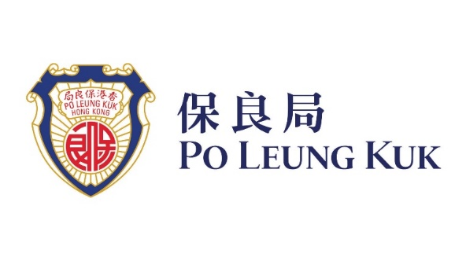



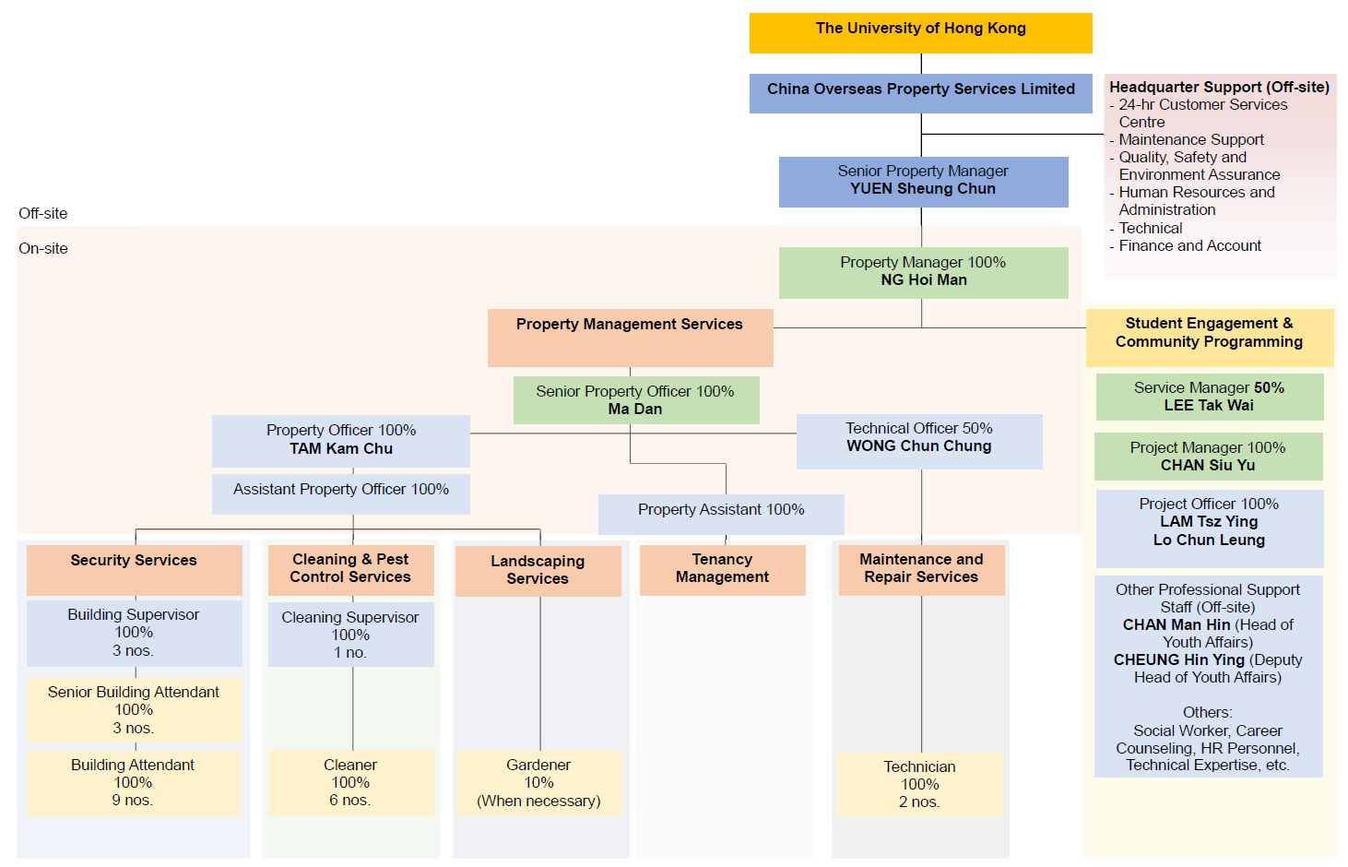

  - CV of Student Engagement and Community Services Provider
THE KEY PERSON FOR THE PROPERTY MANAGEMENT TEAM

Staff  assigned to this contract  (name) | Key person |  | Part 1 – Qualification |  |  |  | Part 2 – Experience
 |  |  | Professional Qualifications |  | Date of award (mm/yy) |  | Year of Post Qualification Experience in the capacity of the Position in this proposal |  | Employment Period
 |  |  |  |  |  |  |  |  | Company |  | Post |  | From  (dd/mm/yy) |  | To  (dd/mm/yy)
Student Engagement and Community Services Provider
LEE Tak Wai |  | Service Manager  (Key Person)  Student Engagement and Community Programming |  | Registered Social Worker |  |  |  | 17  Minimum Requirement for the Position proposed for this proposal:  - A minimum of 10 years’ post-professional qualification experience |  | Po Leung Kuk |  | Service Manager (Youth Affairs) |  | 2021 |  | Present
 |  |  |  | Projective Drawing Analyst |  |  |  |  |  |  |  | Supervisor (Children and Youth) |  | 2010 |  | 2021
 |  |  |  | Certificate of Accredited Mediator |  |  |  |  |  |  |  | Social Worker |  | 2008 |  | 2010
 |  |  |  | Personality Dimensions® Facilitator (Level 1)
 |  |  |  | Everything DiSC® Certified Facilitator
 |  |  |  | Trained facilitator of LEGO® SERIOUS PLAY® method and materials
 |  |  |  | LEGO®-based therapy facilitator
CHAN Siu Yu |  | Project Manager  Student Engagement and Community Programming |  | Registered Social Worker |  |  |  | 17  Minimum Requirement for the Position proposed for this proposal:  - A minimum of 8 years’ post-professional qualification experience |  | Po Leung Kuk Student Guidance and Support Services |  | School social worker |  | 2024 |  | Present
 |  |  |  | Projective Drawing Analyst |  |  |  |  |  | YWCA Jockey Club Family Wellness Centre |  | Social worker (part-time) |  | 2024 |  | 2024
 |  |  |  | Personality Dimensions Facilitator (Level 1) |  |  |  |  |  | Centre for Restoration of Human Relationships |  | School social worker (supply) |  | 2023 |  | 2023
 |  |  |  | Master Practitioner of Neuro Linguistic Programming |  |  |  |  |  | SRBCEPSA Lu Kwong Fai Memorial School |  | School social worker (part-time) |  | 2016 |  | 2023
 |  |  |  |  |  |  |  |  |  | HKFYG Student Guidance Team |  | Youth Work Officer |  | 2012 |  | 2013
 |  |  |  |  |  |  |  |  |  | HKFYG Jockey Club Verbena Youth SPOT |  | Youth Work Officer |  | 2008 |  | 2012
LO Chun Leung |  | Project Officer |  | N/A |  | N/A |  | - At least 4 years’ post-professional qualification experience |  | Po Leung Kuk |  | Youth Worker (Youth Oasis) |  | 2024 |  | Present
 |  |  |  |  |  |  |  | Excellent Global Business Limited |  | Senior Sales and Marketing Officer |  | 2022 |  | 2024 |  | Excellent Global Business Limited
 |  |  |  |  |  |  |  | Empire Hotel Hong Kong |  | Senior Events and Sales Executive  Events and Sales Executive  Events and Sales Executive (Joined as) |  | 2017 |  | 2022 |  | Empire Hotel Hong Kong
LAM Tsz Ying |  | Project Officer  Student Engagement and Community Programming |  | Challenge Course Association of HK, China |  |  |  | 1  Minimum Requirement for the Position proposed for this proposal:  - A minimum of 1 years’ post-professional qualification experience |  | Po Leung Kuk |  | Project Officer |  | 2025 |  | Present
 |  |  |  | (Low Event and High Event) Level 1 Technical Certificate and Assistant Instructor
 |  |  |  | Life Development Institute (Career Development Advisor (NCDA + CCSP))
 |  |  |  | Certificate in First Aid Course – Hong Kong St. John Ambulance
 |  |  |  | Mental Health First Aid - The Mental Health Association of Hong Kong

KEY PERSONS (1) FOR THE Student Engagement and Community SERVICES PROVIDER
Name of the key person: LEE Tak Wai
Current position: Service Manager

Registered Social Worker in Hong Kong under the Social Workers Registration Board since 2001
Accredited General Mediator of Hong Kong Mediation and Arbitration Centre since 2022
16 years’ professional supervisor experience in Youth Services

#Remark: (1) Similar Nature and Scope; (2) Universities, (3) Conversion, Design and Execution and completion of works at Residential Building, Hotel, Hostel; (4) Property Management at Residential building, Hotel Hostel; (5) other relevant experience
EXPERIENCE IN YOUTH SERVICES PROJECTS
COMPANY NAME | EMPLOYMENT PERIOD |  | POST | DUTIES | PROJECT TITLES | Annual Contract Sum ($M) | Details of experience in project (#Remark)
 | FROM  (dd/mm/yy) | TO  (dd/mm/yy
Po Leung Kuk | 2021 | Present | Service Manager | 16 years’ professional supervisor experience in Youth Services  - To be responsible for the planning, development and monitoring of the responsible units;  - To recruit, train and monitor a team of tenant selection and management;  - To communicate with internal departments, governmental departments and community organizations and parties to develop and maintain self-sustaining quality service with good accountability;  - To set up crisis prevention and emergency management policies;  - To prepare accurate and precise documentation and reports;  - To plan and manage budgets and financial issues;  - To handle the administration and personnel management; | Youth Adventure Training Activities/HYAB (25-27)  Youth Adventure Training Activities/HYAB (23-25)  Comprehensive Student Guidance Service (Every Year) | HK$6.5M  HK$6.9M  HK$18M | (5)
 | 2010 | 2021 | Supervisor
 | 2008 | 2010 | Social Worker

